# CHAPTER 1

# INTRODUCTION

## **Background of the Study**

Universities around the world have incorporated the digital revolution. The 21st century university student understands his or her campus in a profoundly different manner from students in decades past. Today, students are enveloped in wireless Internet access, are never more than a few thousand feet away from a computer or laptop, and manage their various student responsibilities and social activities through digital, web-based applications (Roth, et al., 2009).

University campuses are complex and difficult to navigate for the tens of thousands of people that visit in a given year. The campus map is therefore a vital piece of information, challenging in its design in that it covers a large space, needs to incorporate tremendous detail about building, housing, recreation, and access, and, needs to be displayed on a relatively small computer screen (Roth, et al., 2009). This explains why universities and colleges nowadays often have campus maps to visually represent their campuses. These are mainly found in their school websites.

For high school students who have the time and money to travel, visiting a college campus is the best way to get a sense of the students, the faculty, and the feel of the place where they'll be spending their college years (ICEF Monitor, 2012). However, we must keep in mind that some prospective students simply are unable to visit a campus prior to applying or accepting due to monetary or time issues, but by having a campus map online that students can interact with, colleges and universities gain a competitive edge over schools without one (James, 2011). This allows prospective students to get a feel of the campus without actually visiting. An interactive map allows students to examine the campus size, understand where dorms are in relation to academic buildings, and see how far apart potential classes will be from one another.

Creating campus maps prove to be crucial to competing with universities and colleges. The basic driving force for developing a school’s own campus map is staying competitive with what other schools are doing to increase student recruitment and retention and it proves to be crucial to competing with universities and colleges in order to improve visibility in academic industry (James, 2011).

An interactive map concentrates on the interaction between the map and the user. It provides a means to give input and get results (James, 2011).  Interactive maps can reach a wide variety of people at a very low cost and can be modified to reflect changing business requirements and objectives. With interactive maps, organizations can update centralized databases independently of the map (Fitzpatrick, 2002).

One of the few instances interactive maps are useful is a unique representation of a place particularly of a city (AddisMap, 2014) or in a campus setting (Roth, et al., The 21st Century Campus Map: Mapping the University of Wisconsin-Madison, 2009).

In the local setting, prospective students from neighboring cities and provinces would require themselves to visit the campus of MSU-IIT for initial inspection. ICEF Monitor (2012) suggested that a campus map is a necessary requirement for future endeavors of most academic institutions.

### **Narrative Listing of Existing System**

Local studies were pursued in the attempt to fix the problem of visualization of the MSU-IIT campus and Iligan City’s tourist destination spots. Campil, Gomez and Paulin (2010) first addressed the need for a virtual campus map since their preliminary interviews with prospective students and visitors reveal that they experienced several inconveniences in navigating inside the campus. Similarly, Ferrater, Gimeno and Lipa (2013) highlighted the former that the lack of reliable and updated content gave rise to problems for both prospective students and visitors. Further, Bala, Chiu and Yparraguirre (2012) addressed the lack of information regarding potential travel spots in Iligan City's tourism website.

Lakbay IIT was developed by Campil et al. as a solution to the limited visual perspective of the campus and the problems that were brought about from it. It aims to supply the user with 3D visualization of the whole campus in a desktop application. Additionally, it provides building data in Portable Document Format (PDF) that contains room identification key and a short description which can be obtained. Furthermore, it provides a hyperlink to a particular college website (Campil, et al., 2010).

Ferrater et al. (2013) developed the Geolocator Information System of MSU-IIT that features isometric projection. Its services include directing paths for users to follow in navigating within the campus and a search functionality for searching destinations, building information, and key personnel of a department or office. It also offers view functionality for college building floor interiors. The system was built for a kiosk machine under Flash-based architecture supporting touchscreen interaction.

In the context of tourism, Bala et al. (2012) introduced a web-based virtual tour integrated with Google Maps services to promote virtual tourism through Iligan City’s tourism website. It provides a set of multimedia elements such as panoramic views and interactivity of top inns, restaurants, and attractions of Iligan City. It also offers extensive navigation functionality on panoramic data for users to navigate freely.

These systems fail to provide an option to update all of their information, thus making them unsuitable for long term use. The systems stated in this section extensively introduced problems that still need to be addressed and functionalities that can be further developed to fulfill the needs of the current audience.

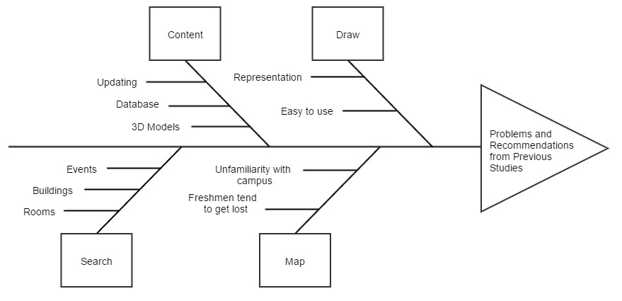

**Figure 1.1** Fishbone Diagram of the System

Figure 1.1 presents a fishbone diagram showing the problems and recommendations stated in the previous studies that are used as guide by the project developers in the design and development of the system.

## **Statement of the Problem**

Campil et al. (2010) developed a 3D virtual map as a desktop application which requires high end hardware capable of rendering 3D models. On the other hand, Ferrater et al. (2013) developed a kiosk-ready Flash-based information system that shows a virtual map of the campus.  Yet, the implementation and maintenance of kiosk machines can be costly in both time and money since they need to be strategically placed all around the campus.

Moreover, these systems were developed as static applications without any form of database and with little to no instructions on how to update relevant data, making the content almost obsolete in the present. Insufficient searching of keywords was also found on the latter where keywords of relevant content are case-sensitive and limited.

This problem is also visible in Suroy Iligan since the information in the system were statically integrated. Appropriately, they recommended adding backend functionalities to make the system dynamic (Bala et. al 2012).

## **Objectives of the Study**

The project developers adhered to the following objectives to guide them in answering the problem stated in the preceding section.

### **General Objective**

As illustrated in Figure 1.1, the project developers aim to develop a web-based interactive map of MSU-IIT by applying the recommendations from the systems of Campil et al., Bala et al. and Ferrater et al. and unifying their functionalities and integrating them into a single dynamic web-based system.

### **Specific Objectives**

To be able to meet the general objective of this project, these specific objectives need to be achieved:

1. To design and develop:
   1. A map module to efficiently render 3D structures of MSU-IIT;
   2. A draw module for drawing buildings as polygons and assigning data on them;
   3. A search module for the application;
   4. A content module with CRUD (Create, Read, Update and Delete) functionalities for all data;
2. To test and evaluate the application.

## **Scope and Limitations of the Study**

This project’s sole focus is on the design and development of an interactive campus map of MSU-IIT. The project developers focused on all the buildings within the campus, excluding external buildings (e.g. College of Medicine and other branches of MSU-IIT Cooperative).

The project also catered the development of a simple tool for drawing buildings as low and lightweight polygons. The system does not allow the user to create and update room perspective as this needs expertise in the field. Users allowed to do so will need to have experience in the field of 3D development.

The project includes a search module that enables the users to search for buildings and colleges. For security purposes, this module does not include searching for specific faculty members, schedules and rooms with unavailable data. The features of the system are divided and classified by the project developers as hard or soft constraints. Hard constraints are the features that are needed to be developed for the system to work significantly. These are considered top priority and should be developed before other features. On the other hand, soft constraints are the features that can be developed after all the hard constraints are integrated. These are usually treated as “add-on” features since they function dependently on the set of hard constraints. These constraints are found in Table 1.2.

**Table 1.1** Hard and Soft Constraints of the System

|  |  |
| --- | --- |
| **Hard Constraints** | **Soft Constraints** |
| Modules:   * Map * Draw * Search * Content | * Geolocation (IP address or GPS); * Room perspective; |

## **Significance of the Study**

The system can help students, faculty members, staff, visitors and prospective students find locations of buildings and/or rooms within campus and also provides them with necessary information about the locations. This also significantly helps in attracting prospective students from distant places to enroll in the university.

The system can also be beneficial to the open source programming libraries used in the design and development of the system especially to OpenStreetMap, OSM Buildings and GLMap. Advancements of the technology used by the developers are contributed to the creators of OSM Buildings and GLMap as these technologies were just recently developed.

## **Project Design**

This section shows the methodology used to develop the web-based interactive map of MSU-IIT.

### **User-Centered Design**

User-Centered Design (UCD) is an approach that supports the entire development process with user-centered activities, in order to create applications which are easy to use and are of added value to the intended users. The biggest cost benefit that UCD can provide is by more accurately defining requirements. Ideally, UCD activities should be integrated with other development activities. They should be planned and managed by the development team. Over time, UCD activities will become common practice, and existing members of the team will be able to carry them out. However, usability skills will most probably be needed within the project and if necessary one or more members of the team should possess these skills (Kangas, 2005).

ISO 13407 Human-centered design process for interactive systems states that *“User-centered design is an approach to interactive system development that focuses specifically on making systems usable. It is a multidisciplinary activity.”*

Several studies have used the User-Centered Design, one of which is the study by Góralski (2009) about developing a three-dimensional interactive map to depict geographical information of a place. Another study that used UCD was by Roth et al. (2009) in his study entitled *The 21st Century Campus Map: Mapping the University of Wisconsin-Madison* and added that “design is based upon an explicit understanding of users, tasks, and environments.”

The web-based interactive map developed for MSU-IIT used the User-Centered Design. Here, development starts with planning and goes through Analysis and Requirements, Design and Evaluation.

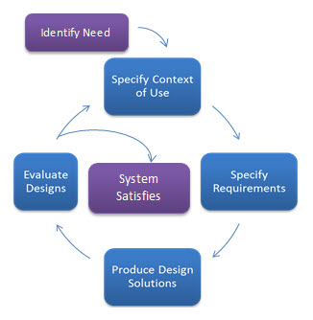

**Figure 1.2** User-Centered Design Process of the System

#### **Planning**

UCD need not be extensive or costly. A few simple activities initial in development will significantly lessen the overall cost of developing a conventional system.

**Choice of Technologies**

The project developers used HTML5 (Hypertext Markup Language) along with CSS (Cascading Style Sheets), Laravel, a PHP framework intended for the model–view–controller (MVC) architectural pattern and JavaScript in developing the interface of the system. To aid in the design and layout of the user interface, the developers used Bootstrap 3. Geospatial mapping API libraries used include OpenStreetMap, OSM Buildings, Leaflet and Leaflet Draw.

To store the collected data in the data gathering process, the developers needed database storage. The system used MySQL since it’s used by most Web applications nowadays.

**Table 1.2** Tools and Scripting Languages

|  |  |
| --- | --- |
| **Front-end** | **Back-end** |
| * HTML5 * Bootstrap * CSS * JavaScript * OpenStreetMap * OSM Buildings * Leaflet * Leaflet Draw | * Laravel framework * XAMPP * PHP * MySQL * AJAX |

#### **Design and Development**

**Wireframes**

Wireframes were created by the developers for the initial concept and layout of the system. A wireframe, also known as a page schematic or screen blueprint, is a visual guide that represents the skeletal framework of a website.Wireframes are created for the purpose of arranging elements to best accomplish a particular purpose.

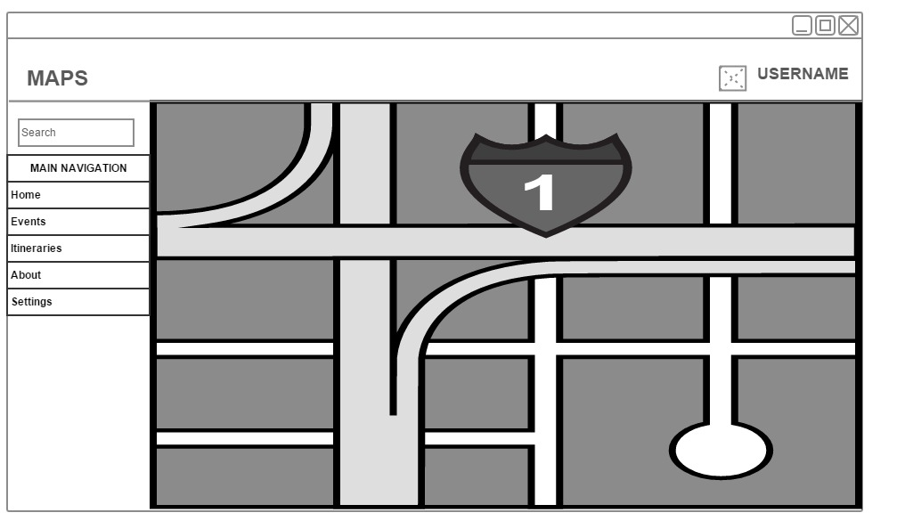

**Figure 1.3** Dashboard Wireframe

##### Prototype Documentation

Attempts to construct an early prototype for this system has already been made through multiple trials. The prototypes were based on different mapping API such as Google Maps, OpenStreetMap and Leaflet. The prototype using Google Maps did not meet the requirements of the developers. Figure 1.3 shows a screenshot of the prototype using Google Maps.

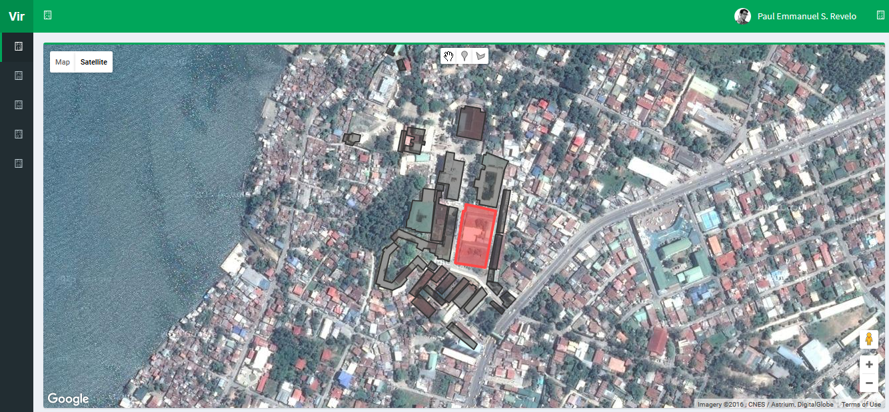

**Figure 1.4** Interactive Map Prototype using Google Maps

After developing the first prototype, the project developers used another mapping API library named OpenStreetMap. This mapping API library, paired with OSM Buildings, a plugin that allows users to load 3D content in maps, met the requirements set by the developers and the consultant, Prof. Erik Louwe Sala. Figure 1.4 shows a screenshot of the prototype using OpenStreetMap and OSM Buildings.

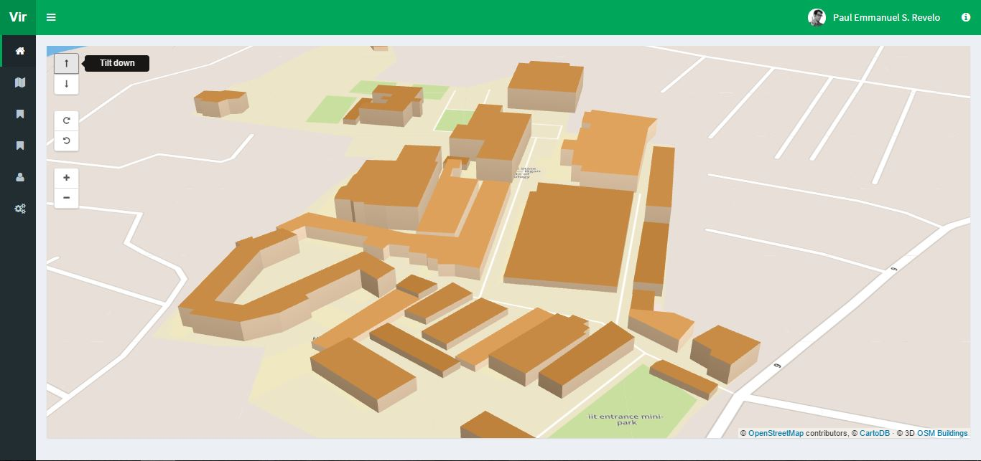

**Figure 1.5** Interactive Map Prototype using OpenStreetMap and OSM Buildings

##### **Module Development**

The specific objectives were interpreted as modules for the system. Proposed features based on the conclusion of the system prototype and usability testing were written as recommendations for further development of the system.

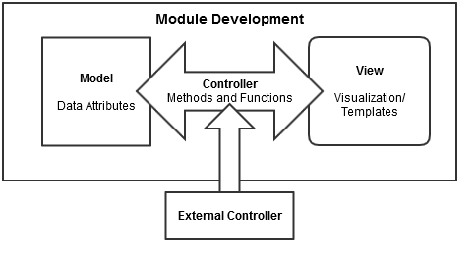

**Figure 1.6** Module Development Process

Initial development of a module started on constructing its model as a class. It is followed by integration process for its controller and testing through visualization on view process. By following programming principles, external controller(s) were made for complexity and readable code. Additionally, its purpose was to provide interconnectivity between modules to be constructed.

**Map Module**

This module counts as a hard constraint of the system as this is the main feature. Development of this module include doing prototypes using visualization technologies (library or framework) and testing whether the technologies used provided what the researchers need for this module. OpenStreetMap was used for the integration of the map and OSM Buildings for the 3D content in the map.

**Content Module**

This module consists of two parts: database and data management. This module is responsible for storing all of the data gathered by the researchers. These include building, structure, room and event information. Also, this module is accountable for the management of these data, which means users can securely access and manipulate the data. Developing this module includes creating a database and creating CRUD (Create, Read, Update and Delete) functionalities using MySQL and JavaScript libraries.

**Draw Module**

This module is responsible in the drawing of low polygon buildings. Developing this module includes the integration of Leaflet’s Draw tools in the map to let the user draw polygons using coordinates, OSM Buildings’ visualization of these coordinates to make 3D buildings and GeoJSON as the initial data format that references to data of buildings involved in the system. These data are from the information provided by the Physical Plant Division.

**Search Module**

This module is responsible for the searching of all data stored in the system. Developing this module includes integrating JavaScript libraries to create the search function and algorithm, HTML to create the elements and CSS to create a style suitable for the overall design.

##### **Module Integration and Testing**

In this section, each module follows MVC as software architectural pattern, where it stands for Model, View, Controller respectively. In the integration process, the module created to a class referring it as a model. This is composed of the modules data attributes. It is followed by a controller of a different class containing different methods and functions in manipulating the module data.

These provide the system security in accessing the modules attributes and their interactivity with other modules. In testing, view component is built for visualization whereas it provides the basic user interface for the module. Additionally, it also shows the interactivity between modules thus gives the programmers initial response if problems or bugs are to be found.

#### **Prototype Refinement**

Refining of the system prototype commences once all of the modules are developed. This phase is monitored by the Product Owner. With this, the researchers follow the SOLID Principles as basis in refining the product for this study.

#### **System Testing**

Testing the system as a whole was done through a usability test using SUS (System Usability Scale). Thirty (30) respondents were asked to participate in the said test. With this, the developers can evaluate and measure the usability of all modules based on the different objectives identified.

##### **Testers**

Target testers should be computer literate and are owners of electronic device(s) capable of web interactivity i.e. users who have computer units and/or mobile devices. The testers are defined not on the basis of race, religion, gender, civil or any classification. Any classification to do so are not for this study aims.

Preliminary questionnaires were handed out to thirty testers. These testers were given the opportunity to test the proposed system.

Based on the testers’ general information, they were classified into four main user groups composed of administrators, students, prospective students and visitors.

##### **Evaluation Process**

Answers supplied by the testers were retrieved in Microsoft Excel format. The data obtained were mainly interpreted to how users interact with the system, including its navigation and design, and dealing quality to other users. Additionally, from each of user group, a mean for the SUS Score was collected and will be evaluated based on the answers of testers.